Yoshida-ke Mitsuka (Elevated house)
-Kuki City designated tangible cultural asset-

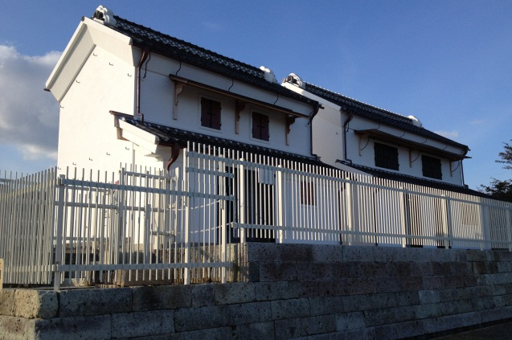
1. “Mitsuka” as municipal cultural asset
“Mitsuka” (or “Mizuka”) refers to a foundation that is elevated in preparation for flooding, including structures on such foundations, if any. Many of them are still seen in low-lying areas in the Kanto region, where people used to suffer from frequent floods.
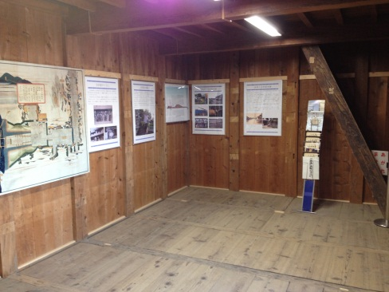
As of September 2012, Mitsukas are confirmed to have built at 204 locations in Kuki City although they no longer exist at some locations (114 at Kurihashi District, 71 at Shobu District, 18 at Washinomiya District, 1 at Kuki District).
The Yoshida-ke Mituska has been confirmed to be the only one left in downtown Kuki. On June 26, 2008, Kurihashi Town (former Kuki City) designated it as a municipal cultural asset, recognizing its historical importance for passing down local wisdom and the history of old inn town Kurihashi to the future generations.
The Yoshida-ke Mitsuka was transferred and rebuilt at the current location on the premises of the Kurihashi Culture Center in March 2012 because of the Tonegawa Levee Improvement Project starting in 2002. The transfer was funded through the project compensation by the state government.

2. About Yoshida-ke Mitsuka
The Yoshida-ke Mitsuka has two traditional warehouses standing on the foundation raised about two meters by using oyaishi, a type of rock. The total area of the Mitsuka is about 290m², measuring 21.5m from east to west and 13.5m from north to south.
The two warehouses are called, from the one near the gate, “Okura” and “Mukogura”, respectively.

3. About Okura and Mukogura
[Okura]
-Year: late Edo era (roughly around 1850)
-Size: 6.3m width, 3.6m deep
-Structure: two-storied warehouse structure with shitaya space, kirizuma roofing using sangawara roof tiles
-Floor area: 54.4 m²
-Items stored: [1st floor] futons(Japanese-style bedding), dishes for ceremonial occasions (wedding, funeral, etc.)
[2nd floor] fine futons, valuables
[Mukogura]
-Year: 1904
-Size: 9.1m width, 5.8m deep
-Structure: two-storied warehouse structure with shitaya space, kirizuma roofing using sangawara roof tiles
-Floor area: 93.2 m²
-Items stored: [1st floor] commercial goods (hardware, etc.) [2nd floor] goods for seasonal festivals

< Yoshida-ke Mitsuka >
Address | 1562 Isaka, Kuki City
Total Mitsuka area | 290.25 m² | Total floor area | 148.01 m²

< Okura and Mukogura >
Warehouse | 1st floor | 2nd floor | Total (m²) | Width (m) | Depth (m)
Okura | 31.23 | 23.14 | 54.37 | 6.363 | 3.606
Mukogura | 52.33 | 41.31 | 93.64 | 9.090 | 5.757
Total | 83.56 | 64.45 | 148.01

4. About Kurihashi-juku (inn-town)
Kurihashi- juku was developed about 400 years ago.
In 1636, the main route to Nikko was finally completed and Kurihara- juku became a busy place as the seventh inn town on the route from Edo, now Tokyo. Kurihara-juku was a popular place also because a checkpoint and a port for river boats were located there.
Historical records show that there were 404 houses, 1,741 people and 25 inns in Kurihashi-juku in 1843, about 170 years ago. There were also a honjin* and wakihonjin in the town.
*honjin: an inn officially designated as a lodging for a daimyo (feudal lord) in the Edo period.
**wakihonjin: a subsidiary inn used by a daimyo’s attendants.

5. About the Yoshida family
The Yoshida family moved from Motokurihashi to Kurihashi among the second wave of migrants. The family currently living in Kurihashi is its 13th generation.
The family used to run businesses dealing with scrap metals and tatami-mat facing. After 1947, when Typhoon Kathleen hit Japan, they changed trades and started hardware business.
The house and other structures in the Yoshidas’ premises were arranged in a way that was typical of houses in inn towns: narrow in width at the entrance but long in depth. A pair of storehouses, used as shops, stood on the town street, behind which lay the living space followed by a barn. The farthest away from the street stood Okura, Mukogura and an Inari-sha shrine on the Mitsuka foundation.
When Typhoon Kathleen hit Japan in 1947, about 20 people in the neighborhood took shelter in the Yoshida-ke Mitsuka for several days.

